XNPV Syntax (Correct)
XNPV(<table>, <values>, <dates>, <rate>)
👉 Parameters:
- table → dataset
- values → cash flow column
- dates → date column
- rate → discount rate (like 0.1 = 10%)

✅ Your Dataset Mapping
From your screen:
Parameter | Your Column
Table | FinanceData
Values | CashFlow
Dates | Date
Rate | 0.1 (example 10%)

🚀 ✅ Basic XNPV Measure (Direct)
XNPV_Value =
XNPV(
FinanceData,
FinanceData[CashFlow],
FinanceData[Date],
0.1
)

💡 What this does
👉 It calculates:
Present Value of all irregular cash flows based on actual dates
👉 Unlike NPV:
- NPV = assumes equal intervals ❌
- XNPV = uses real dates ✅

🚀 🔥 Professional Version (Best Practice)
Use summarized cash flow per date:
XNPV_Value =
XNPV(
SUMMARIZE(
FinanceData,
FinanceData[Date],
"CF", SUM(FinanceData[CashFlow])
),
[CF],
FinanceData[Date],
0.1
)

📊 Real Meaning (Business Interpretation)
If result = ₹ 34.32M (like your screen)
👉 Means:
- After discounting future cash flows at 10%
- Your investment is worth ₹34.32M today

⚠️ Common Errors (Important)
🔴 Error: “Wrong arguments”
✔ Fix → Use full syntax (table, value, date, rate)

🔴 Error: Blank result
✔ Check:
- Date column format = Date
- No null values

🔴 Error: Wrong result
✔ Ensure:
- CashFlow contains both:
  - Negative (investment)
  - Positive (returns)

🎯 XNPV vs NPV (Very Important)
Feature | NPV | XNPV
Time interval | Fixed | Irregular
Accuracy | Medium | High ✅
Real-world use | Limited | Professional finance

🧠 Pro Insight (Interview Level)
👉 Always use:
- XNPV + XIRR together
Because:
- XNPV → gives value
- XIRR → gives return %

🚀 Next Step (Highly Recommended)
Now create:
1️⃣ Combined KPI
Profitability_Check =
IF([XNPV_Value] > 0, "Good Investment", "Bad Investment")

2️⃣ Dashboard
- Card → XNPV
- Card → XIRR
- Line chart → CashFlow vs Date

If you want, I can:
✔ Fix your XNPV error visible in screenshot
✔ Build complete Financial Dashboard (step-by-step)
✔ Give real case study (Amazon / Startup investment)
Just tell me 👍

XNPV (Extended Net Present Value)
🔹 Syntax
XNPV(Table, Value, Date, Rate)
🔹 Parameters
- table→ Select Table
- rate → Discount rate (e.g., 0.1 for 10%)
- values → Cash flow column
- dates → Date column
Concept (Very Important)
Unlike NPV, which assumes:
- Equal time intervals (yearly, monthly)
XNPV uses actual dates, so:
- More accurate
- Used in real financial modeling
Apply on Your Dataset
You already have:
- Table[CashFlow]
- Table[Date]

DAX Measure for XNPV
XNPV_Value =
XNPV(
0.1,
Table[CashFlow],
Table[Date]
)
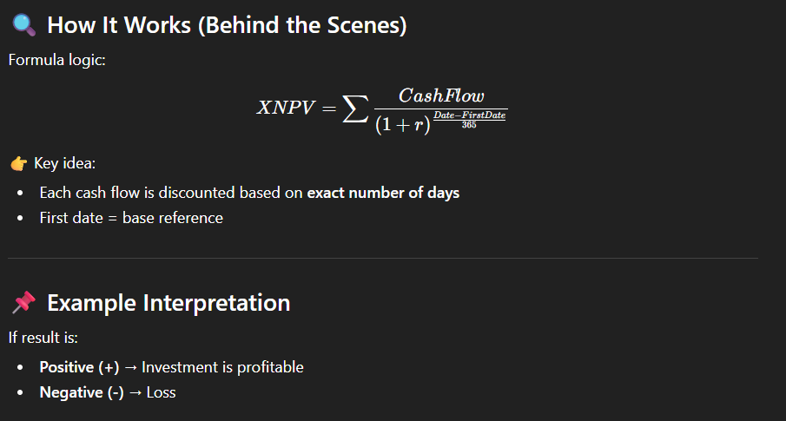

⚠️ Important Conditions (Common Errors)
❌ 1. Dates must be valid
- No blank values
- Must be Date datatype
❌ 2. Cash flow must include:
- At least one negative value (investment)
- At least one positive value (return)
👉 Otherwise → error

Difference: NPV vs XNPV
Feature | NPV | XNPV
Time assumption | Equal intervals | Actual dates
Accuracy | Medium | High
Real-world usage | Less | More
Dataset needed | Values only | Values + Dates

Practical Use Cases
- Project investment analysis
- Loan cash flow analysis
- Startup valuation
- Real estate investment

Pro Tip (Power BI)
Use with:
- Slicer (Date)
- Region / Product filters
👉 Then XNPV becomes dynamic financial model

Bonus (Advanced Measure with FILTER)
XNPV_Filtered =
XNPV(
0.1,
FILTER(Table, Table[Region] = "North"),
Table[Date]
)
👉 Calculates XNPV only for North region

